**Comsats University Islamabad Attock**

**Hospital Management System**

**Submitted by :Raja Hasnain Raza**

**Submitted To: Sir M.Kamran**

 Introduction Hospital are the essential part of our lives, providing best medical facilities to people suffering from various ailments, which may be due to change in climatic conditions, increased work-load, emotional trauma stress etc. It is necessary for the hospitals to keep track of its day-to-day activities & records of its patients, doctors, nurses, ward boys and other staff personals that keep the hospital running smoothly & successfully. But keeping track of all the activities and their records on paper is very cumbersome and error prone. It also is very inefficient and a time-consuming process Observing the continuous increase in population and number of people visiting the hospital. Recording and maintaining all these records is highly unreliable, inefficient and error- prone. It is also not economically & technically feasible to maintain these records on paper. Thus, keeping the working of the manual system as the basis of our project. We have developed an automated version of the manual system, named as “Hospital Management System”. The main aim of our project is to provide a paper-less hospital up to 90%. It also aims at providing low-cost reliable automation of the existing systems. The system also provides excellent security of data at every level of user- system interaction and also provides robust & reliable storage and backup facilities. 1.1 Purpose • The Software is for the automation of Hospital Management. • It maintains two levels of users 1. Administrator Level 2. User Level • The Software includes Maintaining Patient details. • Providing Prescription, Precautions and Diet advice. • Providing and maintaining all kinds of tests for a patient. 1.2 Document conventions • HMS: Hospital Management System • LM: Login Module • RUM: Registered Users Module • NUM: Normal Users Module • AM: Administrator Module • SM: Server Module • DB: Database • DDB: Distributed Database • ER: Entity Relationship

1. [4.](https://image.slidesharecdn.com/finalhmssrschandresh-171022141649/95/hospital-management-system-srs-4-638.jpg?cb=1508681949)1.3 Intended audience This document is to be read by the development team, the project managers, marketing staff, testers and documentation writers. Our stakeholders, company manufacturing associated hardware, company providing embedded operating system, shareholders, and distributors who markets the finished product, may review the document to learn about the project and to understand the requirements. The SRS has been organized approximately in order of increasing specificity. The developers and project managers need to become intimately familiar with the SRS. 1.4 Additional information Marketing staff have to become accustomed to the various product features in order to effectively advertise the product. • System features: Testers need an understanding of the system features to develop meaningful test cases and give useful feedback to the developers. • External Interface Requirements: The hardware developers need to know the requirements of the device they need to build. The marketing staff also needs to understand the external interface requirements to sell the product by describing the user-friendly features of the Hospital Management System. • Non-functional and Functional Requirements: The hardware developers. 2. Overall Description Goals of proposed system: 1. Planned approach towards working: - The working in the organization will be well planned and organized. The data will be stored properly in data stores, which will help in retrieval of information as well as its storage. 2. Accuracy: - The level of accuracy in the proposed system will be higher. All operation would be done correctly and it ensures that whatever information is coming from the center is accurate. 3. Reliability: - The reliability of the proposed system will be high due to the above stated reasons. The reason for the increased reliability of the system is that now there would be proper storage of information. 4. No Redundancy: - In the proposed system utmost care would be that no information is repeated anywhere, in storage or otherwise. This would assure economic use of storage space and consistency in the data stored. 5. Immediate retrieval of information: - The main objective of proposed system is to provide for a quick and efficient retrieval of information. Any type of information would be available whenever the user requires. 6. Immediate storage of information: - In manual system there are many problems to store the largest amount of information. 7. Easy to Operate: - The system should be easy to operate and should be such that it can be developed within a short period of time and fit in the limited budget of the user.
2. [5.](https://image.slidesharecdn.com/finalhmssrschandresh-171022141649/95/hospital-management-system-srs-5-638.jpg?cb=1508681949)Background: A Hospital is a place where Patients come up for general diseases. 1. Hospitals provide facilities like: - • Consultation by Doctors on Diseases. • Diagnosis for diseases. • Providing treatment facility. • Facility for admitting Patients (providing beds, nursing, medicines etc.) • Immunization for Patients/Children. 2. Various operational works that are done in a Hospital are: - • Recording information about the Patients that come. • Generating bills. • Recording information related to diagnosis given to Patients. • Keeping record of the Immunization provided to children/patients. • Keeping information about various diseases and medicines available to cure them. 3. The work is done as follows: - • Information about Patients is done by just writing the Patients name, age and gender. Whenever the Patient comes up his information is stored freshly. • Bills are generated by recording price for each facility provided to Patient on a separate sheet and at last they all are summed up. • Diagnosis information to patients is generally recorded on the document, which contains Patient information. It is destroyed after some time period to decrease the paper load in the office. • Immunization records of children are maintained in pre-formatted sheets, which are kept in a file. • Information about various diseases is not kept as any document. Doctors themselves do this job by remembering various medicines. All this work is done manually by the receptionist and other operational staff and lot of papers are needed to be handled and taken care of.
3. [6.](https://image.slidesharecdn.com/finalhmssrschandresh-171022141649/95/hospital-management-system-srs-6-638.jpg?cb=1508681949)2.1 Product perspective The various system tools that have been used in developing both the front end, back end and other tools of the project are being discussed in this section. 1. FRONT END: JSP, HTML, CSS, JAVA SCRIPTS are utilized to implement the frontend. • Java Server Page (JSP): Different pages in the applications are designed using JSP. A java sever page component is a type of java server that is designed to fulfill the role of a user interface for a java web application. Web development write JSPs as text files that combine HTML or XHTML code, XML elements, and embedded JSP actions and commands. Using JSP, one can collect input from users through web page. • HTML (Hyper Text Mark-up Language): HTML is a syntax used to format a text document on the web. • CSS (Cascading Style Sheets): CSS is a style sheet language used for describing the look and formatting of a document written in a mark-up language. • Java Script: JS is a dynamic computer programming language. It is most commonly used as part of web browsers, whose implementations allow client-side scripts to interact with the user, control the browser, communicate asynchronously, and alter the document content that is displayed. 2. BACK END: The back end is implemented using MYSQL which is used to design the databases. • MYSQL: MySQL is the world’s second most widely used open source relational database management system (RDMS). The SQL phrase stands for structured query. • PHP: PHP is a server-side scripting language designed for web development but also used as a general purpose programming language. PHP code is interpreted by a web server with a PHP processor module, which generates the resulting web page: PHP commands can be embedded directly into an HTML source document rather than calling an external file to process data. • SMS GATEWAY: An SMS gateway allows a computer to send or receive short message services (SMS) transmissions to or from a telecommunications network. Most messages are eventually routed into the mobile phone networks. Many SMS gateways support media conversion from email and other formats. A direct to mobile gateway is a device which has built-in wireless. GSM connectivity. It allows SMS text messages to be sent or received by email, from web pages or from other software applications by acquiring a unique identifier from the mobile phone's subscriber identity module, or "SIM card". Direct to mobile gateways are different from SMS aggregators, because they are installed on an organization's own network and connect to a local mobile network.
4. [7.](https://image.slidesharecdn.com/finalhmssrschandresh-171022141649/95/hospital-management-system-srs-7-638.jpg?cb=1508681949)2.2 Product functions The system will allow access only to authorized users with specific roles (Administrator, Operator). Depending upon the user’s role, he/she will be able to access only specific modules of the system. A summary of the major functions that the software will perform: A login facility for enabling only authorized access to the system. When a patient is admitted, the front-desk staff checks to see if the patient is already registered with the hospital. If he is, his/her Name is entered into the computer. Otherwise a new Patient ID is given to this patient. 2.3 User classes and characteristics 1. Use Case Diagram:
5. [8.](https://image.slidesharecdn.com/finalhmssrschandresh-171022141649/95/hospital-management-system-srs-8-638.jpg?cb=1508681949)2. Class Diagram:
6. [9.](https://image.slidesharecdn.com/finalhmssrschandresh-171022141649/95/hospital-management-system-srs-9-638.jpg?cb=1508681949)2.4 Operating environment Deployment Diagram:
7. [10.](https://image.slidesharecdn.com/finalhmssrschandresh-171022141649/95/hospital-management-system-srs-10-638.jpg?cb=1508681949)2.5 User environment Component Diagram:
8. [11.](https://image.slidesharecdn.com/finalhmssrschandresh-171022141649/95/hospital-management-system-srs-11-638.jpg?cb=1508681949)2.6 Design/implementation constraints 1. Data Flow Diagram: DFD Level 0: DFD Level 1:
9. [12.](https://image.slidesharecdn.com/finalhmssrschandresh-171022141649/95/hospital-management-system-srs-12-638.jpg?cb=1508681949)DFD Level 2:
10. [13.](https://image.slidesharecdn.com/finalhmssrschandresh-171022141649/95/hospital-management-system-srs-13-638.jpg?cb=1508681949)2. Entity Relationship Diagram:
11. [14.](https://image.slidesharecdn.com/finalhmssrschandresh-171022141649/95/hospital-management-system-srs-14-638.jpg?cb=1508681949)3. Activity Diagram:
12. [15.](https://image.slidesharecdn.com/finalhmssrschandresh-171022141649/95/hospital-management-system-srs-15-638.jpg?cb=1508681949)4. State Diagram:
13. [16.](https://image.slidesharecdn.com/finalhmssrschandresh-171022141649/95/hospital-management-system-srs-16-638.jpg?cb=1508681949)5. Interaction Diagram:
14. [17.](https://image.slidesharecdn.com/finalhmssrschandresh-171022141649/95/hospital-management-system-srs-17-638.jpg?cb=1508681949)2.7 Assumptions and dependencies • It is assumed that one hundred compatible computers will be available before the system is installed and tested. • It is assumed that Hospital will have enough trained staff to take care of the system. 3. External Interface Requirements 3.1 User interfaces (GUI design) Input from the user will be via keyboard input and mouse point and click. The user will navigate through the software by clicking on icons and links. The icons will give appropriate responses to the given input. 3.2 Hardware interfaces All components able to be executed on personal computers with Windows OS platforms and other platforms like Linux, Unix. • Operating system: window • Hard disk :40 GB • RAM: 256 MB • Processor: Pentium(R)Dual-core CPU 3.3 Software interfaces All the interfaces will be ASPX pages running within the internet browser. The SMS must integrate with the DB though SQL Interface. The system will be hosted in a web server running on Windows Server 2005. • Java language • Net beans IDE 7.0.1 • MS SQL server 2005 3.4 Communication protocols and interfaces This project can compatible with all platforms. Connections to the system will be over TCP/IP connection, project supports all types of web browsers. I have used database so my system can work offline. • Window
15. [18.](https://image.slidesharecdn.com/finalhmssrschandresh-171022141649/95/hospital-management-system-srs-18-638.jpg?cb=1508681949)4. System Feature 4.1 System Architecture The entire project mainly consists of 7 modules, which are: 1. Admin module 2. User module (patient) 3. Doctor module 4. Nurse module 5. Surgeon module 6. Laboratories module 7. Staff module 4.1.1 Description and priority 1. Patient: In patient module here, we can register the new patient, during registration we enter the basic information regarding patient. There are two types of patient one is inpatient and another is Outpatient. If patient is inpatient then we can check the availability of room in particular ward.
16. [19.](https://image.slidesharecdn.com/finalhmssrschandresh-171022141649/95/hospital-management-system-srs-19-638.jpg?cb=1508681949)2. Appointment Scheduling: In appointment scheduling we schedule the appointment for new patient in which we assign the date, time, department and doctor is available that time. If patient want particular doctor then we can search the doctors scheduling and available time for that doctor. Here we add the urgency and reminder to patient. We can also cancel the appointment of particular patient. 3. Admission: In this module we can search the only admitted patient. Here we can update his details like prescription, notes and reports, measurement, birth details, pregnancies and we can cancel the particular admission. 4. Ambulatory: In this module we can see the information related to patients which are outpatient. Here we can see the department wise appointment and particular day’s outpatient. We can also see the today’s waiting list and also transfer or take over the patient from one department to another department. From here we can also admit the patient. 5. Employee: In this module we can register the new employee, for which we can enter the basic information about employee and his professional details. 6. Doctors: In this module we can view the today’s doctor on call schedule department-wise. Here we can create the duty plan of doctor and edit or update the duty plan of particular doctor. Here we can add/delete the doctor to particular department. 7. Operation Room: Here we can search the patient who is gone through any operation and his detail information like operation date, surgeon, therapy, special notice, operation type, operation room number. Here we can also give the quick view of today’s nurses on standby duty and we can create the duty plan for particular nurse. 8. Laboratories: In this module we have to fill up the form and send the request to laboratory test. Here we can also see the pending request. We can also search the particular patient and view the laboratory information of particular patient. 4.1.2 Action 1. Admin module: • manage department of hospitals, user, doctor, nurse, pharmacist, laboratorist accounts. • watch appointment of doctors • watch transaction reports of patient payment, Bed, ward, cabin status • watch blood bank report • watch medicine status of hospital stock • watch operation report • watch birth report • watch diagnosis report • watch death report 2. user module(patient): • View appointment list and status with doctors • View prescription details • View medication from doctor
17. [20.](https://image.slidesharecdn.com/finalhmssrschandresh-171022141649/95/hospital-management-system-srs-20-638.jpg?cb=1508681949)• View doctor list • View blood bank status • View operation history • View admit history. like bed, ward, ICU etc. • Manage own profile 3. Doctor module: • Manage patient account opening and updating • Create, manage appointment with patient • Create prescription for patient • Provide medication for patients • Issue for operation of patients and creates operation report • Manage own profile 4. Nurse module: • Manage patient account opening and updating • Allot bed, ward, cabin for patients • Provide medication according to patient prescription • Manage blood bank and update status • Keep record of patient operation, baby born and death of patient • Manage own profile 5. Pharmacist module: • Maintain medicine • Keep records of hospitals stock medicines and status • Manage medicine categories • Watch prescription of patient • Provide medication to prescriptions 6. Laboratorist module: • Watch prescription list • Upload diagnostic report • Preview of report files. like X-Ray images, CT scan, MRI reports • Manage own profile 7. Accountant module: • Create invoice for payment • Order invoice to patient • Take cash payment • Watch payment history of patients • Manage own profile 4.1.3 Functional requirements The software provides good graphical interface for the user any administrator can operate on the system, performing the required task such as create, update, viewing the details of the book. Allows user to view quick reports like Book Issues/Returned etc in between particular time. Stock verification and search facility based on different criteria.
18. [21.](https://image.slidesharecdn.com/finalhmssrschandresh-171022141649/95/hospital-management-system-srs-21-638.jpg?cb=1508681949)5. Other Non-functional Requirements 5.1 Performance requirements The performance of our software is at its best when the following are regularly done: • Password Management • Regular Database Archiving • Virus Protection 5.2 Safety requirements Humans are error-prone, but the negative effects of common errors should be limited. E.g., users should realize that a given command will delete data, and be asked to confirm their intent or have the option to undo. 5.3 Security requirements Each member is required to enter an individual Username & password when accessing the software. Administrators have the option of increasing the level of password security their members must use. The data in the database is secured through multiple layers of Protection. One of those security layers involves member passwords. For maximum Security of your software, each member must protect their password. 5.4 Software quality attributes The Quality of the system is maintained in such a way so that it can be very user-friendly. The software quality attributes are assumed as under: • Accurate and hence reliable. • Secured. • Fast Speed. • Compatibility.
19. [22.](https://image.slidesharecdn.com/finalhmssrschandresh-171022141649/95/hospital-management-system-srs-22-638.jpg?cb=1508681949)5.5 Project documentation Hospital management system is a computerized system designed and programmed to deal with day to day operations taking place. The program can look after inpatients, outpatients, records, database treatments, status illness, billings in the pharmacy and labs. It also maintains hospital information such as ward id, doctors in charge and department administering. The purpose of the project is to computerize the Front Office Management of Hospital to develop software which is user friendly, simple, fast, and cost – effective. It deals with the collection of patient’s information, diagnosis details, etc. Traditionally, it was done manually. The project outlines all the process followed to come up with the software that is from analysis to testing the system. 5.6 User documentation This software is developed such that total appearance of the product to make it more user friendly. The operator will be provided with login-id and password. General users with basic computer skills can use this software. Any update regarding the patient’s information from the hospital are to be recorded to have updated and correct values. All the data entered will be correct and up-to-date. This software package is developed using java as front end which is supported by sun micro system, MS SQL server 2005 as the back end which is supported by Microsoft windows Xp. The document only covers the requirement specification for the hospital management system. This document does not provide any references to the other component of the hospital management system. All the external interfaces and the dependencies are also identified in this document. It describes all the details that the software developer need to know for designing and developing the system. This is typically the largest and most important part of the document. User interface is designed in a user-friendly manner and the user, in another end he has to give the order, for that he will interface with keyboard and mouse.
20. [23.](https://image.slidesharecdn.com/finalhmssrschandresh-171022141649/95/hospital-management-system-srs-23-638.jpg?cb=1508681949)6. Other Requirements A degraded mode of operation should be possible in which each system can operate independently of central scheduling. The software shall have failure and error recognition codes acting as a safety net, thus keeping the software from performing any major catastrophic functions. Appendix A: Terminology/Glossary/Definitions list 1. Accident and emergency service: Unplanned services provided to patients who are not admitted to the hospital. 2. Acute: A medical condition that comes on suddenly, and lasts for a limited time. 3. Admission: The administrative process of becoming a patient in a hospital. 4. Aged care unit: This is a specialised facility providing nursing home care services. 5. Bed days: The total number of days for patients who were admitted 6. Cardiology clinic: Hospital facility for non-admitted patients providing services relating to the heart. 7. Dialysis clinic: Hospital facility for non-admitted patients providing artificial kidney function. 8. ED: See Emergency department. 9. Elective surgery: Elective surgery is planned surgery that can be booked in advance 10.Eye surgery: Surgical specialty relating to the eyes and optic nerve. 11.Local Hospital Network (LHN): A Local Hospital Network (LHN) is an organization that provides public hospital services in accordance with the National Health Reform Agreement. 12.Orthopaedic clinic: Hospital facility for non-admitted patients providing services relating to the musculoskeletal system. 13.Overnight admission: A hospital stay in which the patient spent at least one night in hospital. 14.Pre-admission and pre-anaesthesia: Hospital facility for non-admitted patients providing care to patients before surgery. 15.Removal date: Date on which a patient is removed from an elective surgery waiting list. 16.Same day admission: A hospital stay in which the patient is discharged on the same date as they were admitted.

**Some Activity, class and use case diagram are following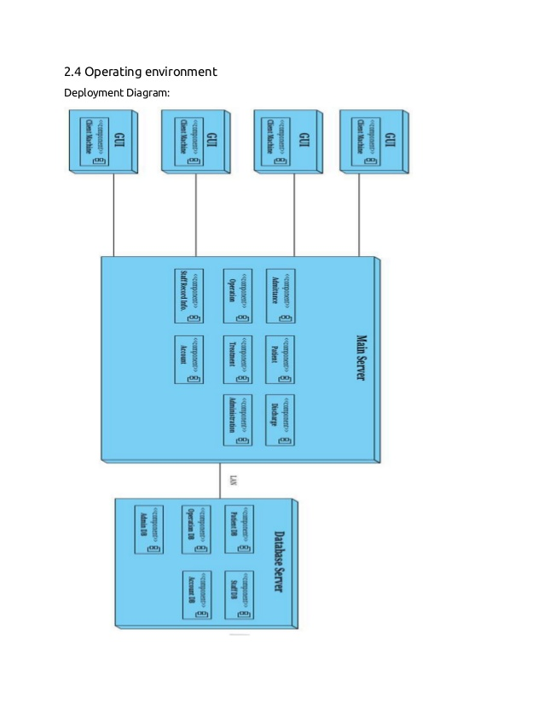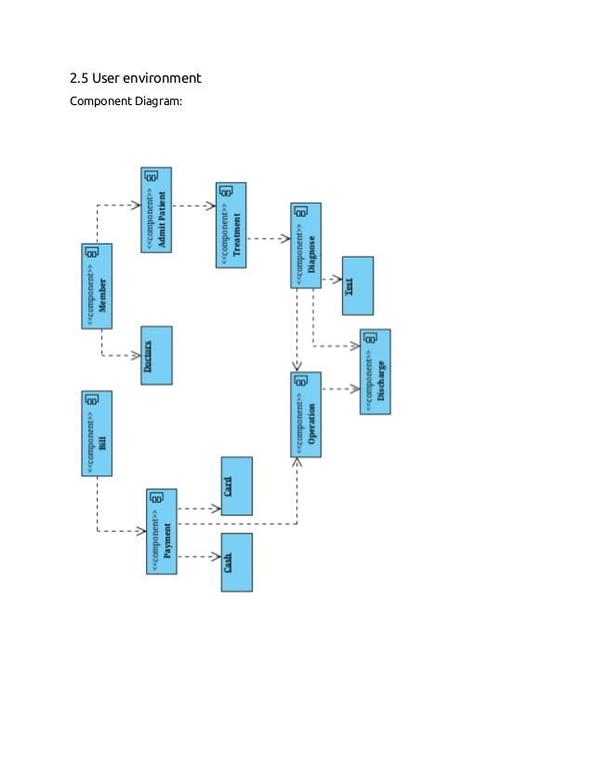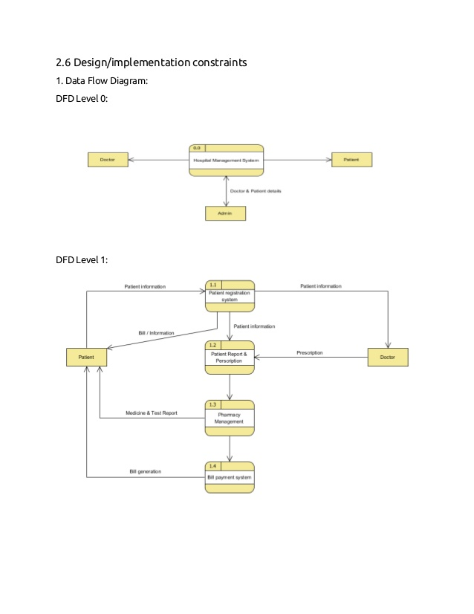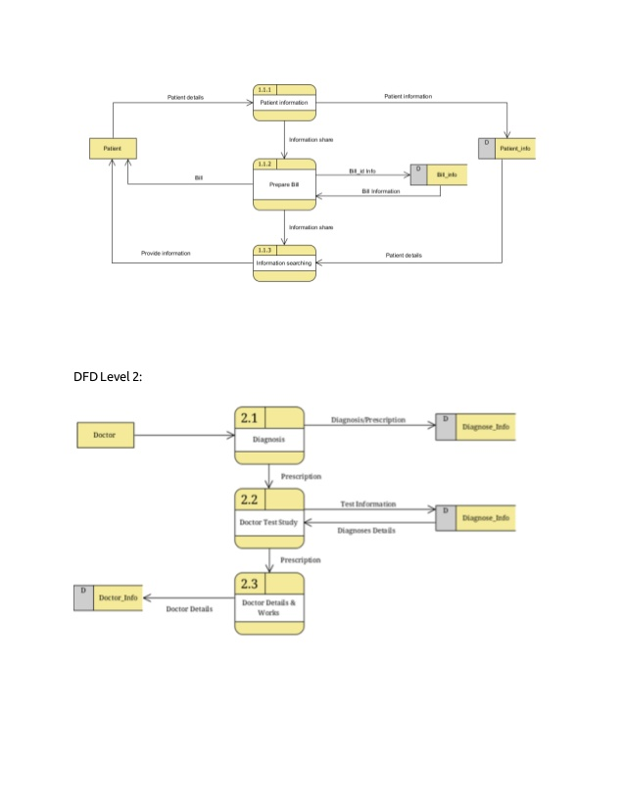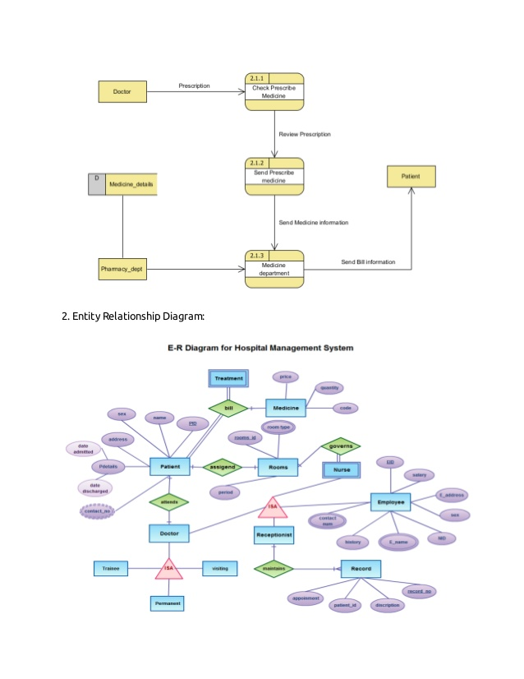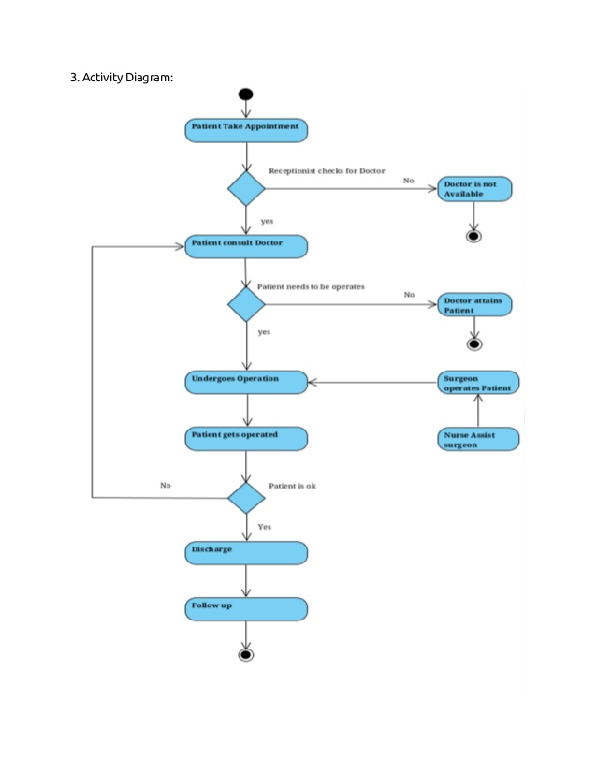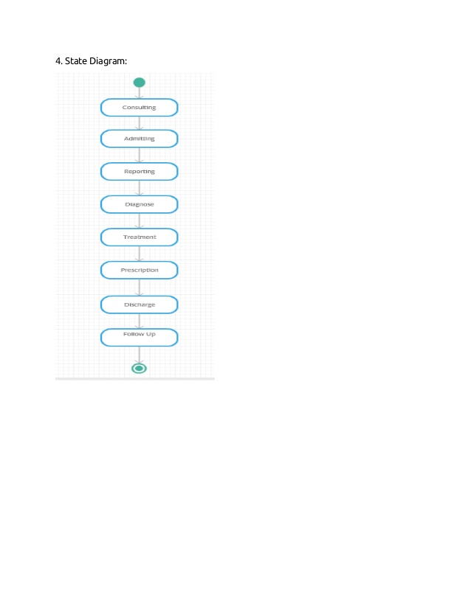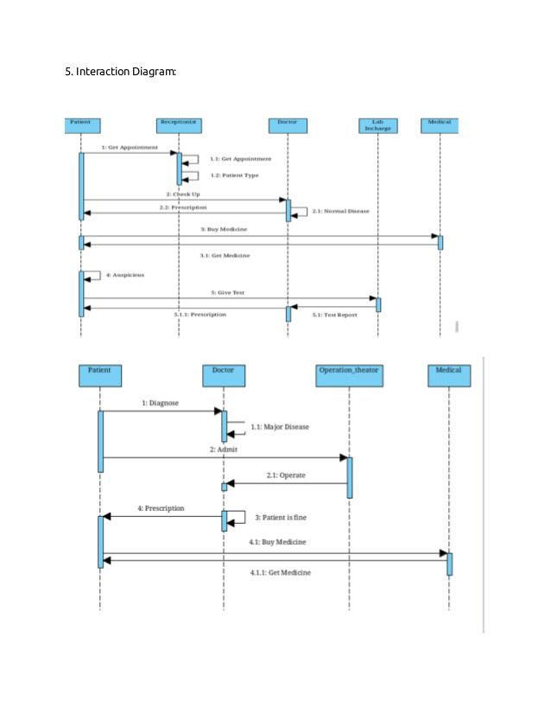 Diagrams And Use Cases are following:**

2. Class Diagram:
 